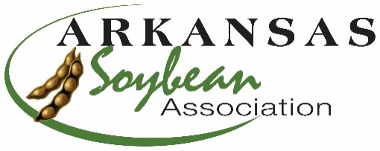
Arkansas Soybean Association
1501 N Pierce, Suite 100
Little Rock AR 72207
501-666-1418
swsoy@aristotle.net
www.arkansassoybean.com

Oliver-Garner Arkansas Soybean Association Memorial Scholarship
The Arkansas Soybean Association is proud to award a scholarship each semester beginning January 2022 for $500 to a student in an Arkansas College. The scholarship is in memory of Andrew C Oliver and Bill Garner, two producers in Arkansas who were active in soybean production and the Arkansas Soybean Association.
1.Scholarship awarded to Junior or Senior majoring in an agriculture related field of study (agronomy, entomology, plant pathology, etc.).
2.Scholarship will be awarded based on grade point average (2.5 minimum GPA), financial need, and leadership participation in extra-curricular activities. Scholarship is renewable for up to 4 semesters (junior and senior years)
3. Applicant will submit a current transcript, and the completed application including an essay explaining your professional career goals relating to the field of agriculture.
4. Application deadlines are: October 30, 2023 (for Fall semester 2023) and February 28, 2024 (extended for Spring semester 2024)
5. Scholarship will be paid to student to use as needed for books, tuition, supplies etc.
6. Scholarship winners will be invited to the Arkansas Soybean Association Annual meeting in January and if unable to attend in person, they are invited to provide a video introducing themselves to the membership.
7. All scholarship information should be sent to:
Arkansas Soybean Association
Scholarship Committee
1501 N Pierce, Suite 100
Little Rock AR 72207

8. Any questions may be directed to Dawn Howe, Executive Director at 501-666-1418 or swsoy@aristotle.net

